Krugmanwelssessentials4e

Questions from Model Chapter

# General Layout

The general layout of sample chapter is a good example to work from. We need to check fonts, margins, and all styling issues. The PDF serves as a model, but we will use basic, standardized, web fonts. Also, some layout features may need to be changed for the e-book, such as single columns, left or right gutter used throughout (i.e. marginal content to left or right of main text), etc.

# Key Terms

There is a key terms section in the XML file with glossary definitions. Should these be maintained on a per chapter basis or for the entire book, in one glossary file?

# Key Terms Quiz

Will the key terms section in each chapter be an interactive matching quiz? If so, where do the answers come from? These cannot be taken directly from the glossary definitions.

# Lists

Many lists have bolded numbering/lettering. Should these be maintained or is the default, non-bolded styling OK?

# Problems Section

Will these be interactive questions? Possibly they are “Show Answer” questions. If so, will answers be for each a/b/c/d item in the alphabetic sub-lists, or is there just one, larger answer and button including all list items in the question?

# Work It Out Section

Should this be kept as a separate A-head section or be incorporated into the Problems section?

# Figures

### Format – Styling

Figures are tabbed and blue in the PDF. We need to settle on a solution for the e-book. Note that the contained images are provided with a white background, rather than transparent, which prevents them being used on a colored background. They will not appear as in the PDF.

An alternate solution would be to cut the entire figure from the PDF, like so:

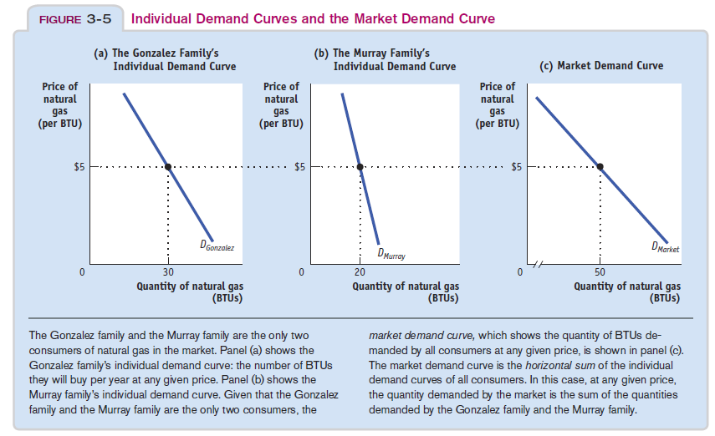

### Multiple images

Some figures have multiple images, some of which are provided as separate files and some of which are merged. Can we follow a single solution, such as merged images, for all figures? That would also simplify the associated supplemental window and click events.

### Intro photos

The sample chapter has two photos on the intro page. They have separate credits and only one has a caption, which is meant to be displayed for both images.

Can we combine these photos? If so, can the credits be incorporated into the image file (is this not a legal requirement)?

Should these intro photos be clickable, with supplemental windows?

# Tables

Most tables are unnumbered, not intended to popup supplemental windows, and are coded as HTML tables (i.e. not images). There are only 3 numbered tables in Chapter 3, two of which are uniquely styled and have more complicated headers. It is suggested that numbered tables be images, which can be cut directly out of the PDF or be separately delivered.

Advantages of numbered tables as images

* Faster to implement
* Maintain complex styling
* Behave like figures, being clickable and popping up supplemental windows with larger versions of the table images

# Features graphics

Some features found throughout the book might be best included in the e-book as graphics, rather than being a more complicated mix of text with positioned graphic elements. Here are a couple examples:



